Using Hibernate
In this lab we will develop classes and Hibernate configuration to persist an EventManager application. The classes in EventManager are:
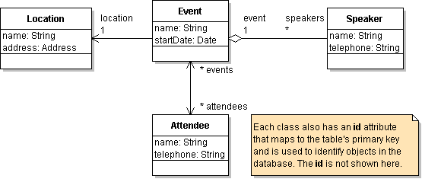

Required Software:
1. Download Hibernate from www.hibernate.org and unzip it to a convenient location for reuse (not inside your project directory); for example (on Windows) c:\java\hibernate or c:\lib\hibernate.
2. Download Log4J from http://logging.apache.org/log4j. Unzip to a convenient location for reuse.
3. Download a database and JDBC driver. We will use Derby since it can be used without setting up a database manager. Download Derby from: http://db.apache.org/derby/derby_downloads.html. Another good lightweight database is HSQLDB, available at www.hsqldb.org.
4. For Eclipse users, the Hibernate Tools for Eclipse are useful (once you understand Hibernate). Download from http://www.hibernate.org/255.html. For Eclipse 3.4 (Ganymede), the release versions of Hibernate Tools don't work, including 3.2.2Beta1. To use Hibernate Tools with Eclipse 3.4, download the latest "nightly build" from JBoss (until Hibernate Tools version 3.2.2 is released). Nightly builds are at: http://download.jboss.com/jbosstools/builds/nightly/latestBuild.html
Unzip the Hibernate Tools in your Eclipse directory.

Exercise 1: Setup Your Project Environment for Hibernate
Your project directory structure should look similar to this:

EventManager/ the project base directory
src/
hibernate.cfg.xml Hibernate configuration file
log4j.properties Log4J configuration file
eventmgr/ base package is "eventmgr"
domain/ package for domain objects
Location.java
location.hbm.xml O-R mapping file for Location class
bin/
hibernate.cfg.xml copied here by IDE during build
log4j.properties copied here by IDE during build
eventmgr/
domain/
Location.class
location.hbm.xml copied here by IDE during build
Referenced Libraries/
Hibernate Library a library contains JARs required
by Hibernate
log4j.jar reference to log4j.jar (not a copy)
derby.jar reference to derby.jar
1. Create an "EventManager" project in your IDE. You can use any IDE but these instructions refer to Eclipse.
2. In the Eclipse New Project wizard, choose "src" as the base directory for source code and "bin" for output files.
3. Add jar files using the "Libraries" tab in the New Project wizard, or select Project -> Preferences, choose "Java Build Path" and select the "Libraries" tab.
3a. Click "Add External JAR" and add log4j.jar (maybe named log4j-1.2.x.jar).
3b. Click "Add External JAR" and add derby.jar (or a database of your choice).
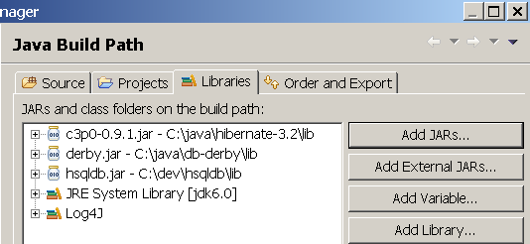
4. Also in the "Libraries" dialog, create a User Library for Hibernate.
4a. Click "Add Library..."
4b. Select "User Library" and click Next. Click "User Libraries". 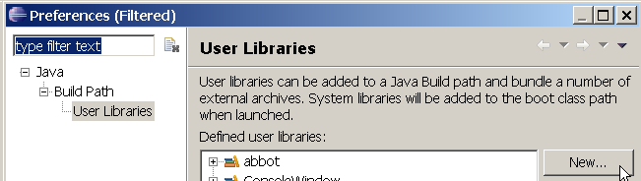
4c. Click "New..." and enter the name Hibernate for the library.
4d. Now you have a library named Hibernate as shown below.
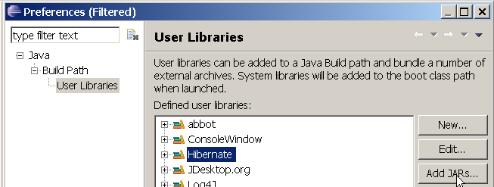
4e. Click "Add Jars..." and add these JAR files from the Hibernate distribution (the ZIP file that you unpacked before). hibernate.jar is in the root of the distribution; the others are in the lib directory.

Please note Hibernate (recent versions) jars required can be downloaded from following GitLab repository:

http://wosggitlab.wipro.com/rajshad/TopGear-Hibernate-Jars.git

Library Name Contains
hibernate3.jar build & runtime Hibernate classes
antlr.jar ANother Tool for Language Recognition
asm.jar ASM bytecode library, used by cglib bytecode provider
cglib.jar bytecode generator, creates objects and proxy objects
commons-collections.jar Apache Commons Collections, to create collections objects
commons-logging.jar Apache Commons adaptor for logging
dom4j.jar XML configuration and mapping parser
ehcache.jar a cache provider, required if no other cache provider is set
jta.jar JTA API, required for standalone operation (outside application server)
c3po.jar JDBC connection pool. Not required but desirable.
4f. Add the Javadoc for Hibernate to the "Hibernate.jar" item so that Eclipse will provide context sensitive documentation for Hibernate. Expand the "Hibernate.jar" item, select "Javadoc location" and add the Hibernate doc/api directory. The result will look like:
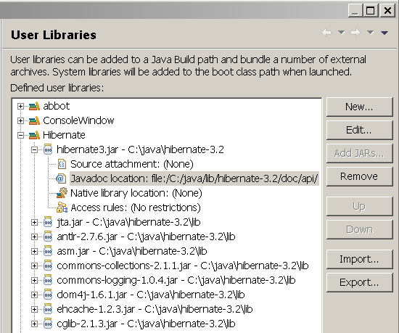
5. Now you are finished setting up the project libraries. The next step is to add configuration files for log4j and Hibernate.
6. In the project "src" directory create a log4j.properties file. You can copy this file from [hibernate-dist-dir]/etc/log4j.properties. A basic log4j file to log errors to the console and other messages to a file looks like:
### define log streams (appenders) and the base log level (warn).
log4j.rootLogger=warn, stdout, file
### direct error messages to stdout ###
log4j.appender.stdout=org.apache.log4j.ConsoleAppender
log4j.appender.stdout.Target=System.out
log4j.appender.stdout.layout=org.apache.log4j.PatternLayout
log4j.appender.stdout.layout.ConversionPattern=%d %5p %c{1}:%L - %m%n
log4j.appender.stdout.threshold=error
### direct messages to file hibernate.log ###
log4j.appender.file=org.apache.log4j.FileAppender
log4j.appender.file.File=hibernate.log
log4j.appender.file.layout=org.apache.log4j.PatternLayout
log4j.appender.file.layout.ConversionPattern=%d %5p %c{1}:%L - %m%n
7. In the project "src" directory, create a hibernate.cfg.xml file. You can copy a sample file from [hibernate-dist-dir]/etc/hibernate.cfg.xml, but you must edit it for your project and database. A minimal Hibernate config for using MySQL looks like this:

<?xml version="1.0" encoding="UTF-8"?>
<!DOCTYPE hibernate-configuration PUBLIC
"-//Hibernate/Hibernate Configuration DTD 3.0//EN"
"http://hibernate.sourceforge.net/hibernate-configuration-3.0.dtd">
<hibernate-configuration>
<session-factory>
<property name="hibernate.dialect">
org.hibernate.dialect.MySQLDialect</property>
<property name="hibernate.connection.driver_class">
com.mysql.jdbc.Driver</property>
<property name="hibernate.connection.url">
jdbc:mysql://localhost:3306/”databasename”></property>
<property name="hibernate.connection.username">
root
</property>
<property name="hibernate.connection.password">
wipro123
</property>
<property name="show_sql">true</property>
<property name="hbm2ddl.auto">validate</property>
<mapping resource="eventmgr/domain/Location.hbm.xml" />
</session-factory>
</hibernate-configuration>
This configuration file refers to a class mapping file named "Location.hbm.xml". You will create that file in the next exercise.

Exercise 2: Create a Location class and Hibernate Mapping
1. Define a Location class in the eventmgr.domain package that implements this class diagram:
Location
- id : Integer
- name : String
- address : String
+ Location( )
+ Location( name, address )
+ getId( ) : Integer
- setId( Integer ) : void
+ getName( ) : String
+ setName( String ) : void
+ getAddress( ) : String
+ setAddress( String ) : void
+ toString( ) : String
This is a simple class in standard "JavaBean" form. It has a default constructor, a parameterized constructor (for convenience), and get/set methods for each attribute. Only Hibernate should set the id, so declare setId() to be private (Hibernate can access private methods).
Also add a toString method to display useful data, such as this:
public String toString( ) {
return String.format( "[%d] %s at %s", id, name, address );
}
2. In the same package (eventmgr.domain) create a Hibernate mapping file for the class. The file is named (by convention) Location.hbm.xml.
<?xml version="1.0"?>
<!DOCTYPE hibernate-mapping PUBLIC
"-//Hibernate/Hibernate Mapping DTD 3.0//EN"
"http://hibernate.sourceforge.net/hibernate-mapping-3.0.dtd">
<hibernate-mapping package="eventmgr.domain">
<class name="Location">
<id name="id">
<generator class="native"/>
</id>
<property name="name"/>
<property name="address"/>
</class>
</hibernate-mapping>
3. To simplify getting a SessionFactory, define a class named HibernateUtil that contains static methods for getting a singleton SessionFactory and creating a new Session. You can download this instead of writing it yourself. Put it in a "service" or "util" package of your project. The class diagram is:
HibernateUtil
-sessionFactory : SessionFactory
+getSessionFactory( ) : SessionFactory
+getCurrentSession( ) : Session
+openSession( ) : Session
The main purpose of HibernateUtil is to create a singleton sessionFactory. A SessionFactory is usually created like this:
Configuration config = new Configuration( );
SessionFactory sessionFactory =
config.configure().buildSessionFactory( );
The call to configuration.configure() processes your hibernate.cfg.xml file.
4. Finally, create a class to save and retrieve objects to/from the database. The class should have 4 methods, as shown here:
LocationTest
- sessionFactory : SessionFactory
+saveLocations( ) : void
+testRetrieve( ) : void
+testUpdate(name: String, addr: String): void
+main( args : String[ ] ) : void
Here is the code to save and then retrieve locations from the database:
import static java.lang.System.out;
public class LocationTest {

private static SessionFactory factory =
HibernateUtil.getSessionFactory();

/** save some locations */
public static void saveLocations() {
Session session = factory.openSession( );
Location loc1 = new Location();
loc1.setName("Kasetsart University");
loc1.setAddress("Pahonyotin Rd, Bangkok");
Location loc2 = new Location();
loc2.setName("Mahidol University");
loc2.setAddress("Salaya, Nakorn Pathom");

out.println("Saving locations...");
out.println( loc1 );
out.println( loc2 );

Transaction tx = session.beginTransaction();
session.save( loc1 );
session.save( loc2 );
tx.commit();
session.close();
out.println("Locations saved");
}
/** retrieve some events from the database */
public static void testRetrieve() {
out.println("Retrieving locations...");
Session session = factory.openSession();
Query query = session.createQuery("from Location");
Transaction tx = session.beginTransaction();
List list = query.list( );
// print the locations
for( Object loc : list ) out.println( loc );
tx.commit();
session.close();
out.println("Done retrieving");
}

public static void main(String[] args) {
testSave();
testRetrieve();
testUpdate("Kasetsart University", "Kampaengsaen");
testRetrieve();
}
5. Run this and see that the locations are being saved and retrieved. You can add some other locations of your choice.
You can see changes in the database by running the Derby "ij" utility in a command window.
WARNING: the Derby embedded driver allows only 1 connection to a database. If ij is connected to your database when you try to run TestLocation, the program will fail to connect to database. If you want to view the database while running your program, run a separate database server process and change the configuration to client/server mode. (My HTML notes describe how to do this.)
cmd> /somepath/derby/bin/ij
ij> connect 'jdbc:derby:/temp/eventmgr';
ij> describe Locations;
ij> maximumdisplaywidth 25;
ij> select * from Locations;
ij> quit;
6. Modify "testRetreve" to only retrieve locations in Bangkok. Change the query to:
Query query = session.createQuery(
"from Location l where l.address like '%Bangkok%'");
7. Write a testUpdate method to get a requested location (by name) and change its address.
/** change address of a location */
public void testUpdate( String name, String newAddress ) {
out.println("Updating "+name +"...");
Session session = HibernateUtil.openSession( );
Transaction tx = query.beginTransaction();
Query query = session.createQuery(
"from Location where name=:name");
query.setParameter("name", name );
List list = query.list( );
if ( list.size() == 0 ) out.print("No location named "+name);
else {
// change first location that matches
Location loc = (Location) list.get(0);
loc.setAddress( newAddress );
out.println( loc );
}
tx.commit();
session.close( );
}
Modify the main method like this:
public static void main(String[] args) {
saveLocations();
testRetrieve();
testUpdate( "Chulalongkorn University","Rama IV Rd, Bangkok");
testRetrieve( );
}

Exercise 3: Add the Event class and an Association to Location
Create an Event class in eventmgr.domain that has an association to Location. Since many Events can use the same location this is a many-to-1 relation.
Event
- id : Integer
- name : String
- startDate : Date
- location : Location
+Event( )
+getId( ) : Integer
-setId( Integer ) : void
+getName( ) : String
+setName( String ) : void
+getStartDate( ) : Date
+setStartDate( Date ) : void
+getLocation( ) : Location
+setLocation( Location ) : void
+toString( ) : String
1. Write the Event class with get/set methods for each attribute. setID() is private. Also write a toString method that returns a String containing the id, name, and startDate.
2. Create an Event.hbm.xml file in the same package as Event.java.
<?xml version="1.0"?>
<!DOCTYPE hibernate-mapping PUBLIC ...remainder not shown... >
<hibernate-mapping package="eventmgr.domain">
<class name="Event" table="EVENTS">
<id name="id">
<generator class="native"/>
</id>
<property name="name"/>
<property name="startDate" column="start_date"
type="timestamp"/>
<many-to-one name="location" column="location_id"
cascade="save-update">
</class>
</hibernate-mapping>
The new construct here is "many-to-one" for persisting a reference to another object. The attribute cascade="save-update" means that when an Event is saved or updated, the associated Location should also be saved or updated.
If you omit cascade="save-update", then it is your responsibility to save the Location object before committing the Event in Hibernate.
3. Write an EventTest class to save and retrieve an event named "Java Days". Use one of the locations that you already saved in LocationTest. Since we have configured Hibernate to recreate the schema each time, you need to rerun the LocationTest.saveLocations() method first.
This is a partial listing:

package eventmgr.test;
import static java.lang.System.out;
public class EventTest {
/** save some events to database */
public static void saveEvents( ) {
Event event = new Event( );
event.setName("Java Days");
event.setStartDate( new java.util.Date(108,Calendar.JULY,1) );

Session session = HibernateUtil.getCurrentSession();
Transaction tx = session.beginTransaction();
Query query = session.createQuery(
"from Location where name=:name");
query.setParameter("name", "Kasetsart University");
List list = query.list();
event.setLocation( (Location)list.get(0) );
out.printf("Saving event: %s\nLocation: %s\n",
event, event.getLocation() );
session.save( event );
tx.commit();
// getCurrentSession creates a session that is bound to a
// single
out.println("Event saved");
}
This time we created a Session using HibernateUtil.getCurrentSession( ) which calls sessionFactory.getCurrentSession(). getCurrentSession creates a Session that is bound to a single transaction. When you commit the transaction the session is also closed. This is different from openSession() which creates a session that can be used for several transactions.
3b. Write a testRetrieve( ) method yourself. Retrieve all events and print their name, date, and Location.
The main method would look like this:
public static void main(String[] args) {
// recreate the locations because we told Hibernate
// to recreate the schema each run.
LocationTest.saveLocations( );
saveEvents();
testRetrieve();
}
4. Write a testUpdate(String name, Location newLoc) method to move the event to a new location. First get the event from the database (by name), then change the location before closing the session. You should see a new location in the database and an updated event.
Query query = session.createQuery("from Event where name=:name");
query.setParameter( "name", name );
List list = query.list();
if ( list.size() == 0 ) out.println("Event not found");
else event.setLocation( newLoc );

Exercise 4: Add Speakers to Event
An Event has one or more speakers. Define a Speaker class and a one-to-many relation from Event to a Speaker class using a Set.
1. Create a Speaker class in eventmgr.domain with a default constructor and a parameterized constructor to set the name and telephone. Declare setId( ) as private to prevent application code from changing the id.
Speaker
- id : Integer
- name : String
- telephone : String
+ Speaker( )
+ Speaker( String, String )
- setId( Integer ) : void
+ get/set methods for all attributes
+ equals(Object o): boolean
+ hashCode( ): int
+ toString( ): String
2. Create a mapping file eventmgr/domain/Speaker.hbm.xml. The file is similar to Location.hbm.xml.
3. Add Speaker.hbm.xml to the Hibernate configuration file as a resource:
<session-factory>
...
<mapping resource="eventmgr/domain/Speaker.hbm.xml"/>
</session-factory>
4. Modify the Event class to include a set of Speakers. This is a unidirectional association, so the Java code is easy. The application should use addSpeaker( speaker ) rather than setSpeakers( ), so declare setSpeakers( ) as protected.
public class Event {
private Integer id;
private String name;
private Location location;
private Date startDate;
private Set<Speaker> speakers;

public Set<Speaker> getSpeakers() { return speakers; }

/** set the event speakers (for use by Hibernate) */
protected void setSpeakers(Set<Speaker> speakers) {
this.speakers = speakers;
}

/** add a speaker. For use by application. */
public void addSpeaker( Speaker speaker ) {
if ( ! speakers.contains(speaker) ) speakers.add(speaker);
}
The Hibernate Reference Manual always uses untyped collections, such as "Set speakers", rather than "Set<Speaker> speakers". In my tests the parameterized sets (as in the code above) work correctly, and have the advantage of type safety.
5. Now modify Event.hbm.xml to add the speakers attribute as a "set" containing a one-to-many relation using a foreign key (event_id) that will be part of the SPEAKERS table:
<set name="speakers" cascade="save-update">
<key column="event_id"/>
<one-to-many class="Speaker"/>
</set>
6. Write a test method to add speakers to an event. Add speakers while the event is connected to an open session so that the speakers will be saved when the session is closed or flushed.
7. Write a test method to retrieve an event and display the speakers, too. For example:
public static void testRetrieve( ) {
System.out.println("Retrieving events...");

Session session = HibernateUtil.openSession( );
Transaction tx = session.beginTransaction();
// get all the events
Query query = session.createQuery( "from Event" );
List<Event> list = (List<Event>)query.list( );
tx.commit();
//(1)
for(Event e : list ) {
out.printf("%s on %tD\n", e.toString(), e.getStartDate() );
out.printf(" Location: %s\n", e.getLocation() );
out.print( " Speakers:");
for(Speaker s : e.getSpeakers() ) out.print(" "+s.getName() );
out.println();
}
//(2) close the session
session.close( );
}

Exercise 5: Lazy Instantiation of Object References
The Event class contains a reference to a Location object and references to several speakers in a Set. An Event could have thousands of speakers. Retrieving all the speakers from the database when the Event is queried would require a lot of database accesses.
For efficiency, Hibernate does not create the objects referenced by Event when you query an Event. Instead, it fetches and instantiates the objects when your code accesses them, such as:
Location loc = event.getLocation( ); // now hibernate creates the Location object
This is called lazy instantiation. It is important to understand this because it effects how you use Hibernate in your application.
1. In the previous code example, move the session.close( ) statement from //(2) to position //(1) and run the program again. This time you should get an exception such as:
org.hibernate.LazyInitializationException: could not initialize proxy - no Session
at org.hibernate.proxy.AbstractLazyInitializer.initialize(...
This is because we closed the session before the object references were instantiated.

Two Solutions to Lazy Instantiation Errors
(1) The most efficient solution is to access references of persistent objects while they are attached to an open session. After the references have been instantiated you can close the session.
When a session is closed, a persistent object become "detached". It can be reconnected to a new session using session.update( obj ) or session.saveOrUpdate( obj ).
(2) Tell Hibernate not to use lazy instantiation for a particular association or for all instances of a class. You can set lazy="false" in a class mapping or as attribute of many-to-one, set, etc.
2. Edit Event.hbm.xml and set lazy="false" for both the location and speakers attributes:
<class name="Event" table="EVENTS" lazy="true">
<id name="id" column="id" >
<generator class="native"/>
</id>
<property name="name"/>
<property name="startDate" column="start_date"
type="timestamp" />
<many-to-one name="location" column="location_id"
class="Location" cascade="save-update" lazy="false"/>

<set name="speakers" cascade="save-update" lazy="false">
<key column="event_id"/>
<one-to-many class="Speaker"/>
</set>
3. Run the test program again. There should not be an exception.

